# Chapter : Implementation



## Tools Used

### Development Tools

#### HTML and CSS

Both HTML and CSS is used this project to create the basic structure and the user interface components in the views.

#### JS along with jQuery

This project uses JS and jQuery to provide interactivity and visual appeal of the web pages as well as making asynchronous calls to the database.

#### PHP with Laravel

In his project PHP with Laravel framework is used to implement the back-end logic and the ORM structurers. It is the base of the project that handles all the core logic and algorithms as well as providing a MVC structure for development. The system is built using PHP 8.0 and Laravel 9.47.0.

#### PHP Storm IDE

The system is developed using PHP Storm IDE with student license. It was chosen as it provides a better, leaner, and easier development interface and a better IntelliSense compared to other alternatives. The availability of free student license allowed for the project cost to be reduced.

#### MySQL

The core database of the project is built in MySQL using PHP as PHP offers an easy integration of the MySQL databases.

#### GitHub with Git

Git is a version control system. And GitHub is an online tool that uses git for version control and team collaboration. The combination of these tools was used for project versioning and code collaboration within the project team.

#### XAMPP server

In this project the XAMPP server allowed the simulation of the Apache server to run the PHP scripts and implement the MySQL database.

### Design and Documentation Tools

#### diagrams.net

The project uses diagrams.net to prepare the various UML diagrams like use-case diagram and activity diagram.

#### Microsoft Project

In this project Microsoft Project is used as the project analysis tool that allowed for the schedule analysis and planning using work breakdown structure and Gantt charts.

#### Microsoft Word

Microsoft Word is a word processor software. It is used during the report and proposal preparation for the project.

#### Microsoft PowerPoint

In this project, Microsoft PowerPoint is used for preparing the presentation slides during the proposal submission and defence, mid-term defence, and final defence.

## Database Implementation

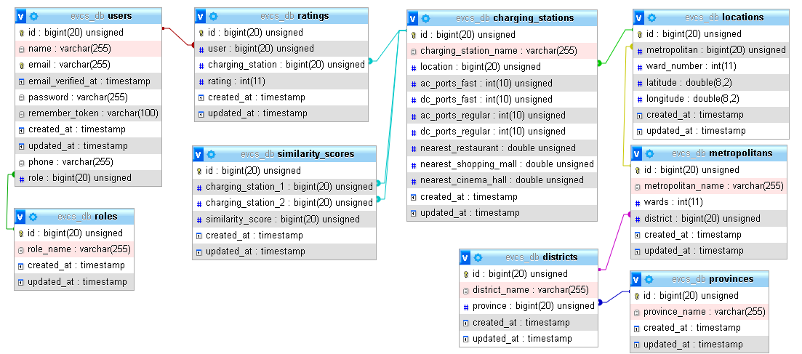

Figure .1: Database implementation

## Algorithm Implementation

This system uses item-based approach and a memory-based method to implement collaborative filtering. The system implements vector cosine-based similarity to compute the similarity score required for the memory-based approach. The algorithm is implemented in two phases. The first phase is the computation of similarity scores between two charging stations while the second phase is the execution of the recommendation system using weighted average.

### Phase 1: Similarity between charging stations using cosine similarity

The first phase in the implementation of algorithm in the system is the implementation of cosine similarity between the charging stations. Unlike the general approach of using the user ratings itself for the computation of similarity scores to generate a similarity matrix, this system used the attributes of the charging stations itself to factor into the computation of the similarity matrix. The system calculates the similarity scores using the cosine similarity as mentioned in section 4.2.3 of this document.

$$S_{c}\left(A, B\right)=\frac{\vec{A}. \vec{B}}{\left|\left|\vec{A}\right|\right| . \left|\left|\vec{B}\right|\right|}= \frac{\sum_{i=1}^{n}{{\vec{A}}_{i}.{\vec{B}}_{i}}}{\sqrt{\sum_{i=1}^{n}{{\vec{A}}_{i}^{2}}}. \sqrt{\sum_{i=1}^{n}{{\vec{B}}_{i}^{2}}}}$$

Here, A and B are the two charging stations vectors whose similarity scores are to be computed and $S_{c}$ is the similarity score obtained. The attributes of the charging stations that contribute to the computation of similarity scorers are:

* Number of Type 1 AC charging ports, AC regular charging ports
* Number of Type 2 AC charging ports, AC fast charging ports
* Number of CHAdeMO charging ports, DC regular charging ports
* Number of Combined Charging System (CCS) charging ports, DC fast charging ports
* Distance from the nearest restaurant
* Distance from the nearest shopping mall
* Distance from the nearest cinema hall

The distances are first transformed into discrete values using a discretisation method. The distances are discretised based on the distance value. The discretisation transformation method is implemented so that the large distance values can be transformed into smaller values so that it is easier to compute. The distance is not as sensitive so the discretisation induced data loss is not a major issue. The discretisation is done as:

Table .1: Discretisation of distance

|  |  |  |
| --- | --- | --- |
| S.N. | Distance | Discretised |
| 1 | >500 | 0 |
| 2 | >450 and <=500 | 1 |
| 3 | >400 and <=450 | 2 |
| 4 | >350 and <=400 | 3 |
| 5 | >300 and <=350 | 4 |
| 6 | >250 and <=300 | 5 |
| 7 | >200 and <=250 | 6 |
| 8 | >150 and <=200 | 7 |
| 9 | >100 and <=150 | 8 |
| 10 | >50 and <=100 | 9 |
| 11 | >0 and <=50 | 10 |
| 12 | =0 | 0 |